Logistic Regression (Admission + Regularized Microchip) – 1-Page Summary

Problem Statement
Two classic binary classification tasks: (1) predict university admission from two exam scores (linearly separable-ish), and (2) predict microchip quality from two test scores that require a non-linear decision boundary. The goal is to implement logistic regression from first principles (sigmoid, cost, gradient, GD) and then add L2 regularization + polynomial feature mapping so the model can capture the circular pattern in the microchip data.

Solution Strategy
• Implement g(z)=1/(1+e^{-z}) and verify scalar/vector behaviour.
• Code the binary cross-entropy cost and its gradients (loop + fully vectorized).
• Run gradient descent; plot linear decision boundary for the admission data.
• Map features to degree-6 polynomials; add λ‖w‖² regularizer; learn a closed non-linear boundary.
• Provide sklearn LogisticRegression alternate, threshold / λ / noise simulations, and audience-adapted narratives.

Solution
Admission model reaches ~91 % training accuracy with a straight decision boundary. After polynomial expansion (27 features) and modest L2 regularization (λ≈1) the microchip classifier reaches ~82 % accuracy and recovers the classic closed contour. Accuracy falls when λ becomes large (under-fitting) or when training noise is injected—exactly the bias-variance trade-off the simulation section illustrates.
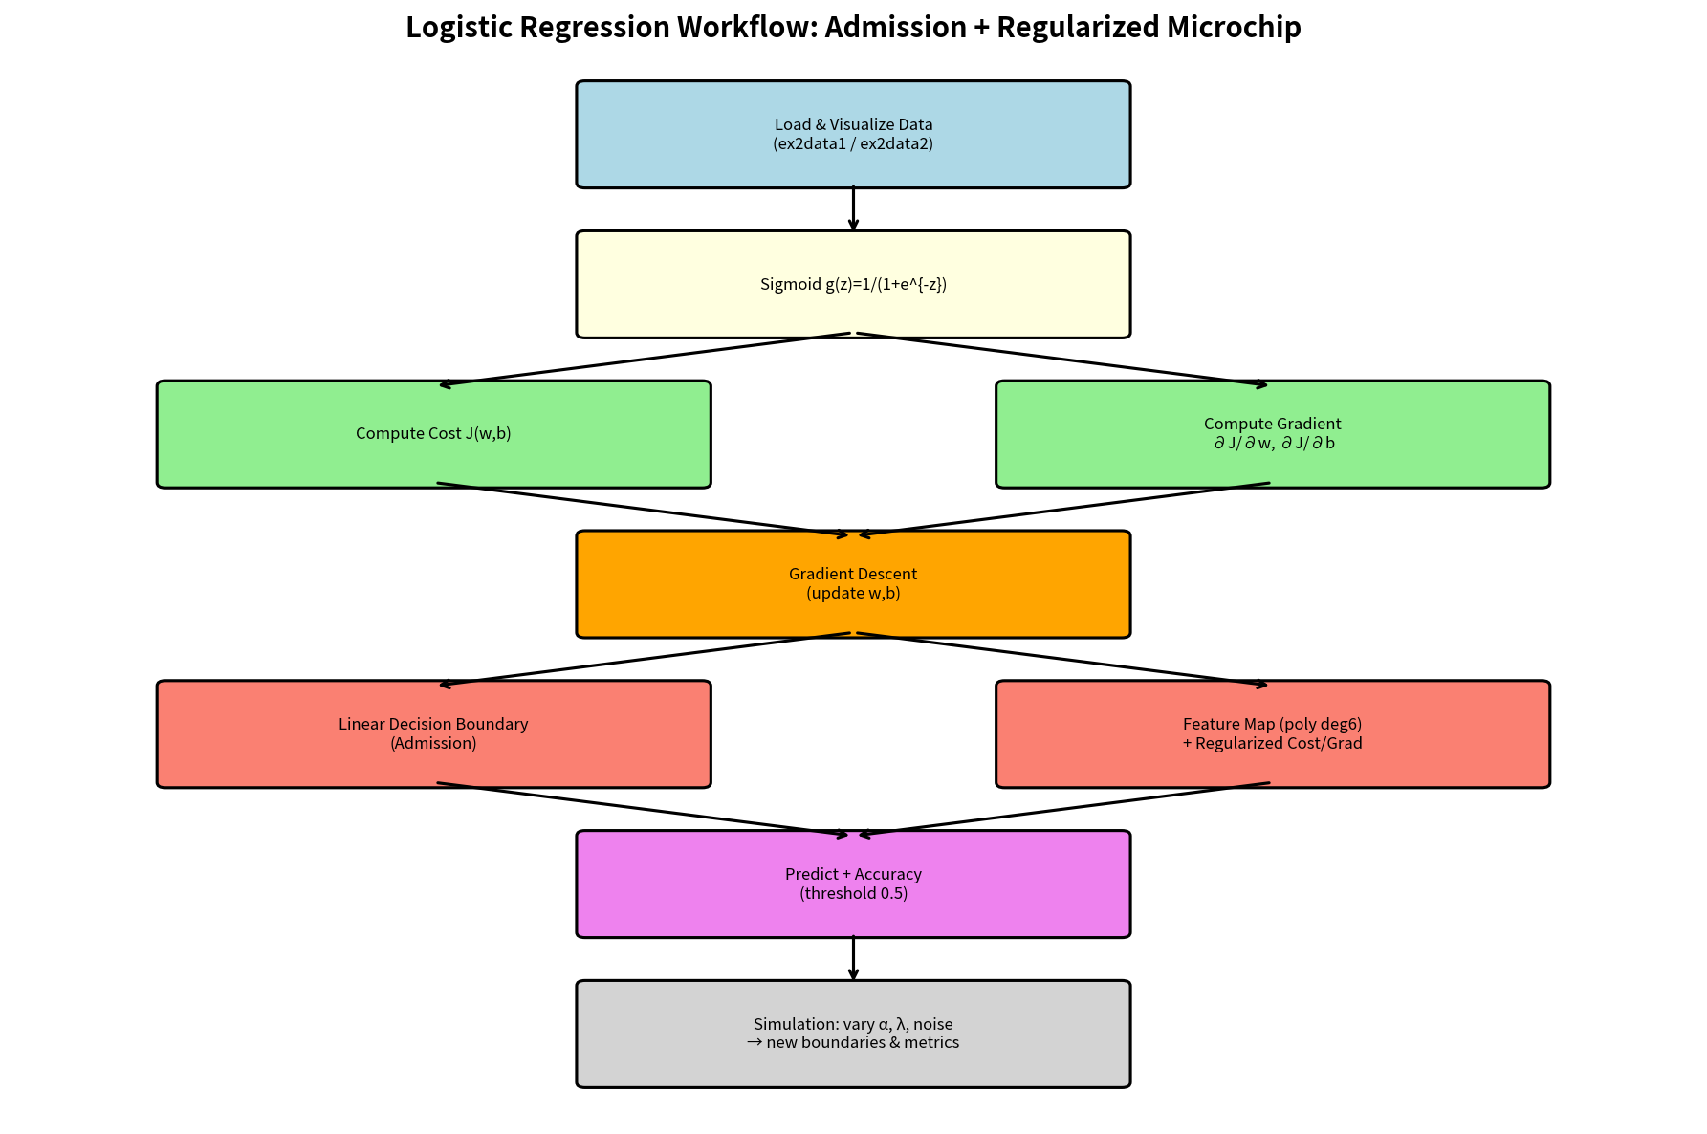
Figure 1 – End-to-end workflow (data → sigmoid → cost/grad → GD → boundary → simulation)
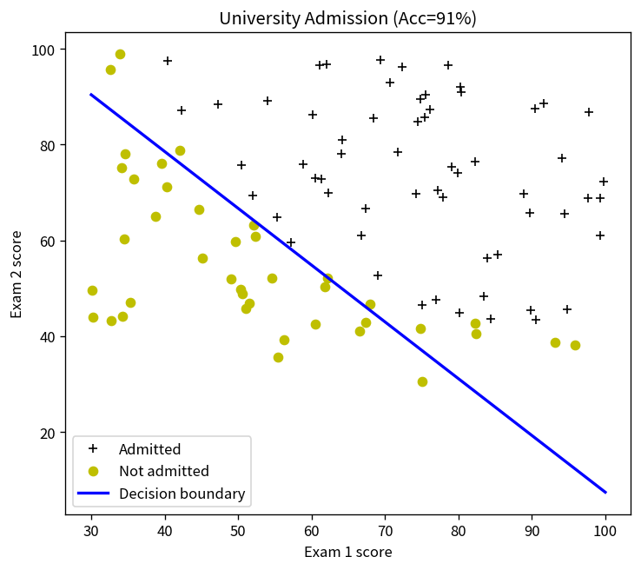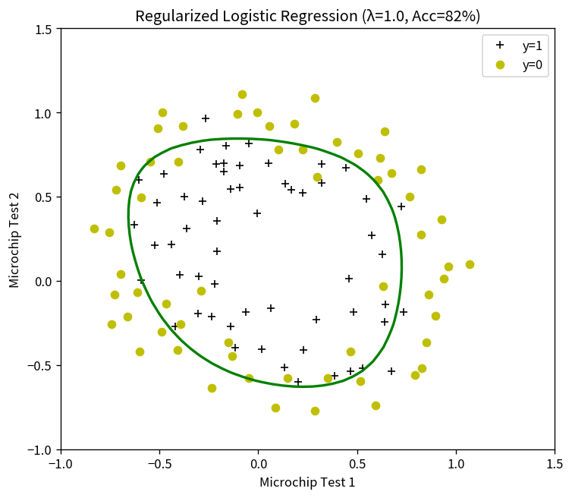
Figure 2 – Linear boundary (admission, left) vs regularized non-linear boundary (microchip, right)

Key Takeaways
• Logistic regression turns a linear score into a calibrated probability via the sigmoid; the 0.5 threshold is a policy choice, not part of the model.
• Feature mapping + L2 regularization lets a linear classifier capture non-linear decision regions without switching to a non-linear model class.
• Always visualise the boundary; numerical accuracy alone can hide over- or under-fitting.
• Audience matters: technical supervisors want cost/gradient derivations and residual diagnostics; executives want the decision boundary picture and the accuracy-versus-λ curve.
• The reusable template and simulation cells make it easy to re-run the same pipeline on any two-feature binary problem.

